34.35: a) 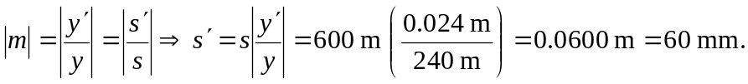
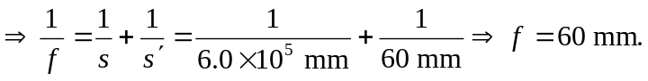 So one should use the 85-mm lens.
b) 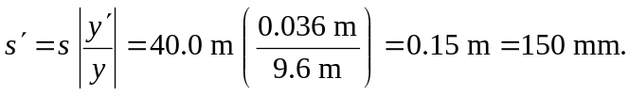
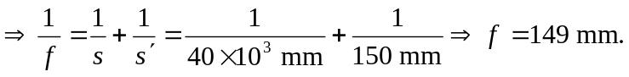 So one should use the 135-mm lens.

